[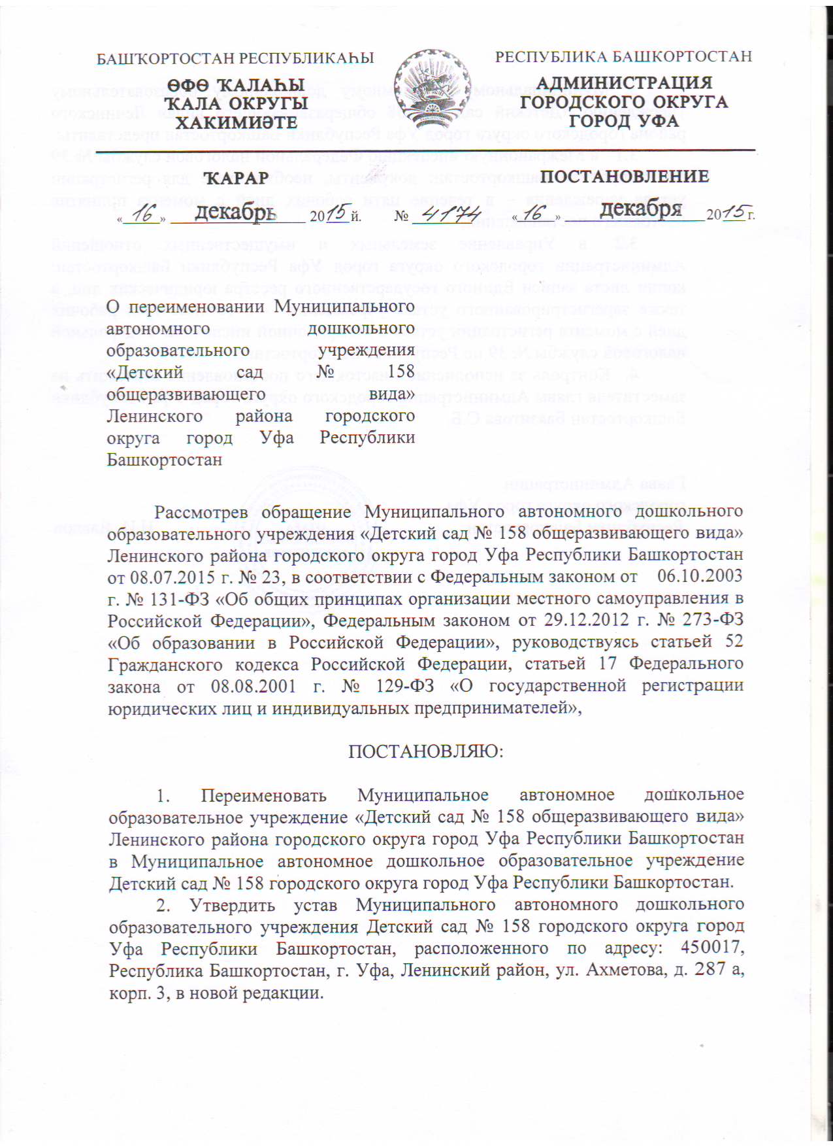](http://158.детсад-уфа.рф/wp-content/uploads/2016/01/%D0%9F%D0%BE%D1%81%D1%82%D0%B0%D0%BD%D0%BE%D0%B2%D0%BB%D0%B5%D0%BD%D0%B8%D0%B5-1.bmp)

[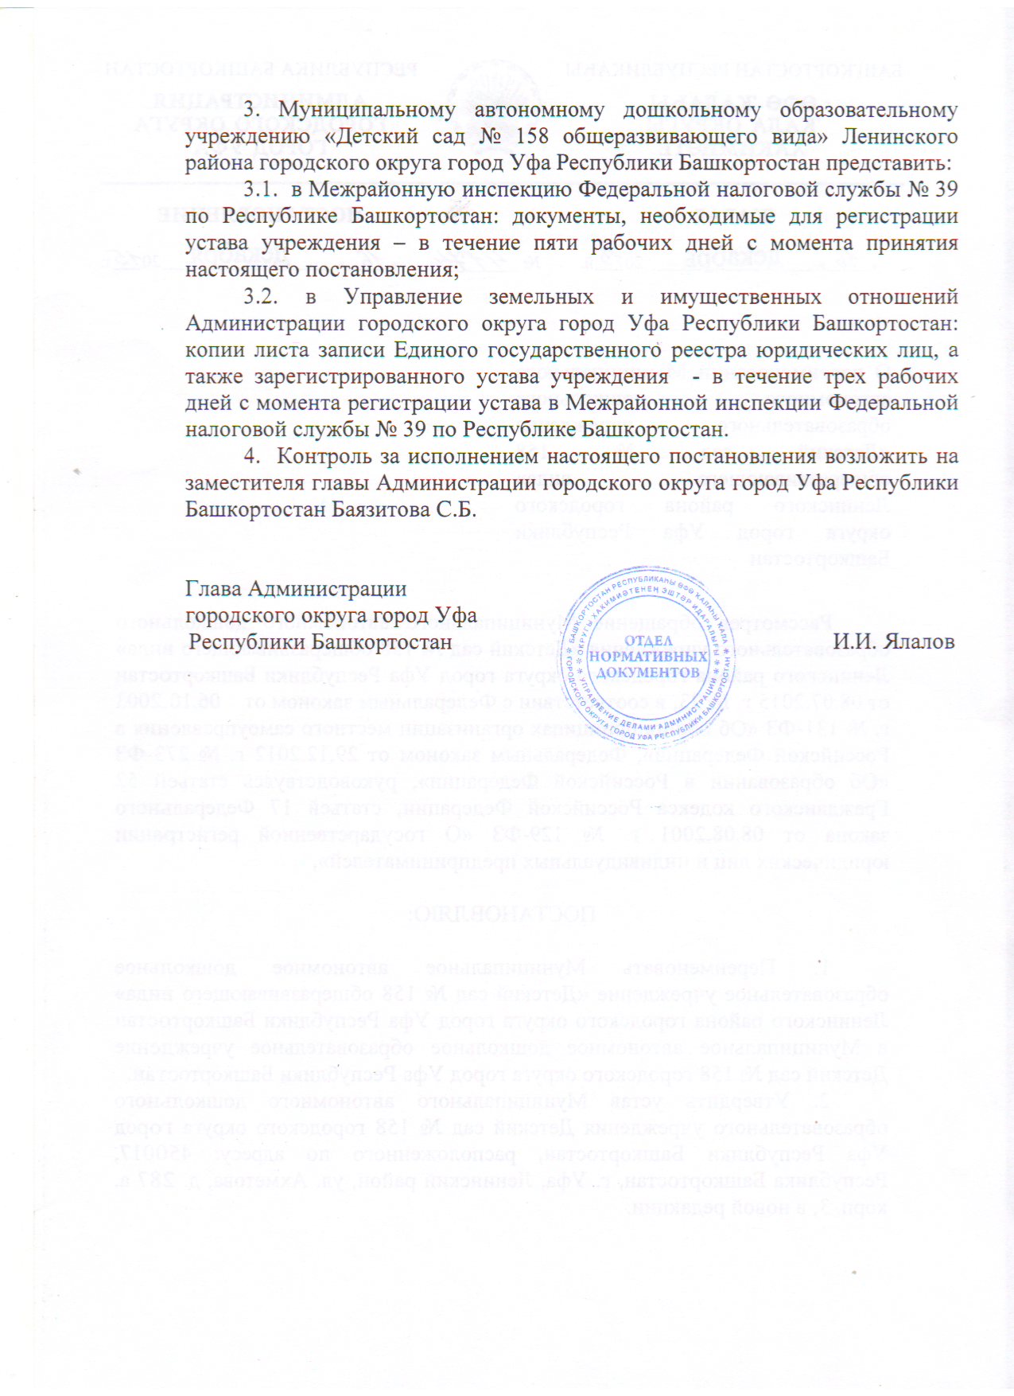](http://158.детсад-уфа.рф/wp-content/uploads/2016/01/%D0%9F%D0%BE%D1%81%D1%82%D0%B0%D0%BD%D0%BE%D0%B2%D0%BB%D0%B5%D0%BD%D0%B8%D0%B5-2.bmp)